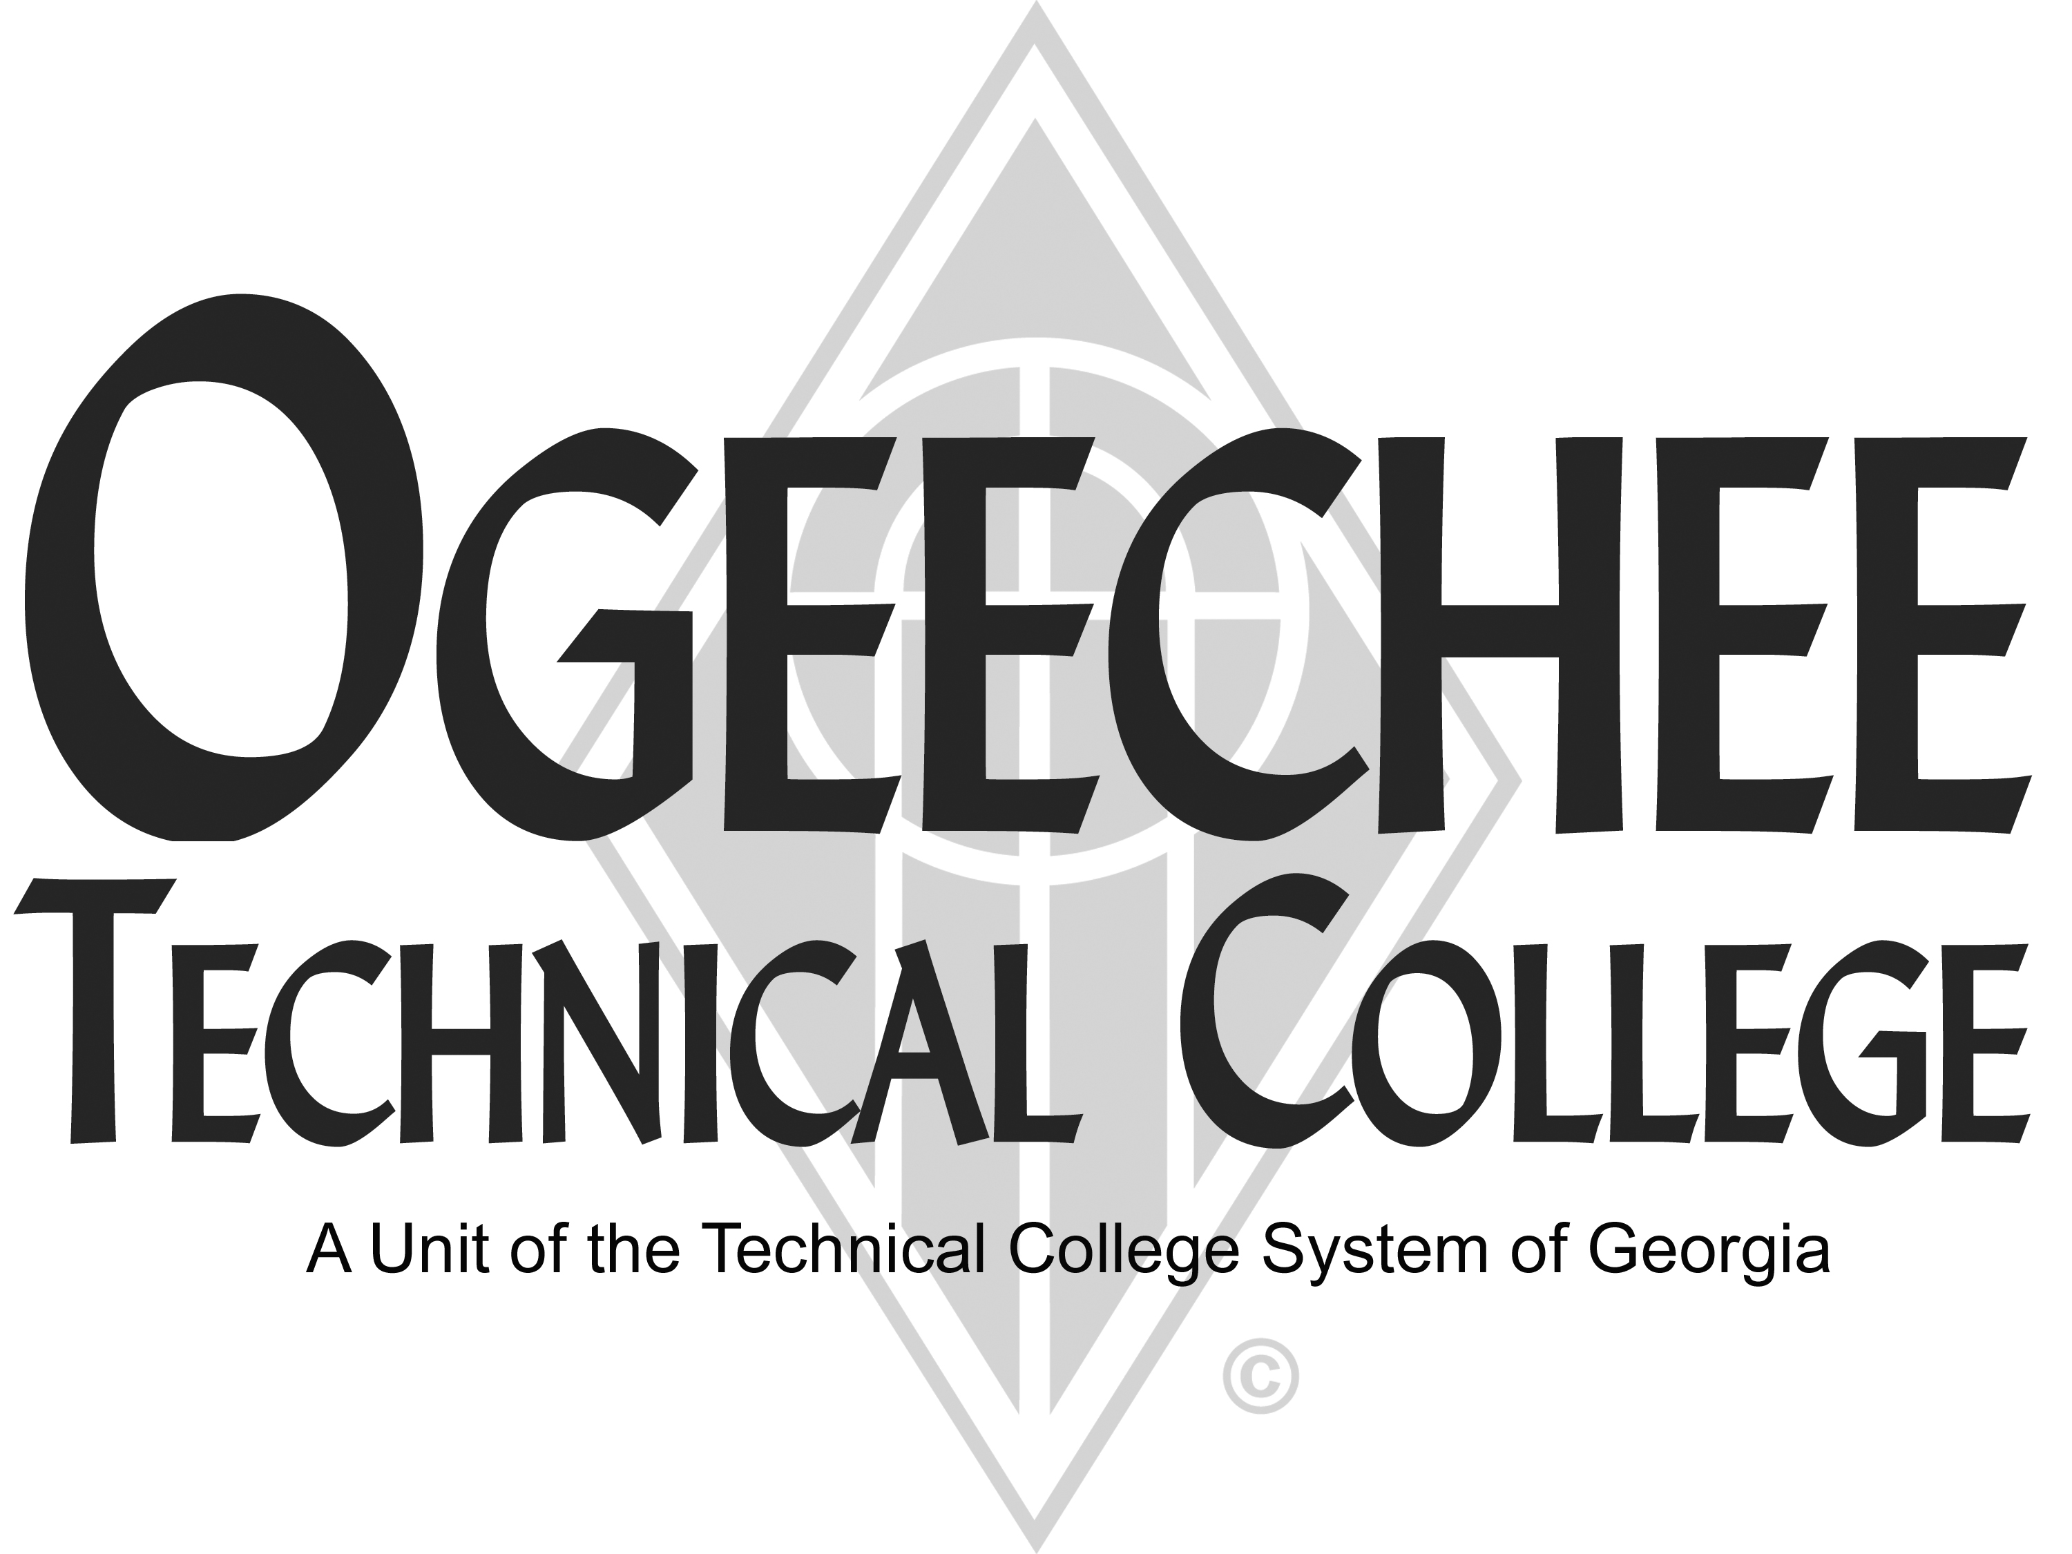
POSITION ANNOUNCEMENT(S)
POSITION TITLE: | Veterinary Technology Professional Laboratory Assistant (Part Time)  This is an applicant pool – active position may not be available
POSITION DESCRIPTION:
Under general supervision, assist full time faculty to instruct students in the Veterinary Technology Program. The position assists in evaluating student progress in attaining goals and objectives. The position may involve teaching traditional day and/or evening classes Monday through Thursday, up to, but no more than 28 hours a week. Maintain lab environments and assist in creating and facilitating lab activities with student groups. To ensure safety and security requirements are met in the training area. Assist in maintaining equipment and inventory. Position is employed on an individual academic term basis.
MINIMUM QUALIFICATIONS:
- Must pass a criminal background check
- Must be vaccinated for rabies
- An Associates’ degree from an accredited college or university in Veterinary Technology.
- Georgia Veterinary Technician license in good standing.
- Knowledge of the Veterinary Technician National Examination requirements on practical application and written testing.
- Two or more years in-field work experience as a Veterinary Technician in a clinical setting.
- Knowledge of principles, basic methods, materials, techniques, and terminology of laboratory testing.
- Ability to perform assigned laboratory tasks according to prescribed procedures.
- Must have excellent written and verbal communication skills.
- Basic computer skills.
PREFERRED QUALIFICATIONS:
- A Bachelor’s degree from an accredited college or university in Biology, Chemistry or closely related field.
- Teaching experience at the postsecondary level.
PHYSICAL DEMANDS:
The position requires performing physical activities, such as but not limited to, working with the canines and felines, horses, cows, and/or small ruminants, lifting heavy items (up to 50 lbs. unassisted), bending, standing, climbing, and walking for three (3) to four (4) continuous hours at a time. The work is performed in campus buildings in a classroom/lab environment. The exposure to dirt, dust, grease, machinery with moving parts, chemicals, and fumes is possible in the laboratory environment.
SALARY/BENEFITS:
Commensurate with qualifications /Non-benefits eligible.

APPLICATION DEADLINE:
Open Until Filled
TO APPLY: Please submit an online application using the OTC online job center website. A criminal history records check is required as a condition of employment. Copies of all transcripts should be submitted at the time of application for faculty positions. Official transcripts are required upon employment. For more information, please contact the Director for Human Resources at employment@ogeecheetech.edu.
Ogeechee Technical College does not discriminate on the basis of race, color, creed, national or ethnic origin, sex, religion, disability, age, political affiliation or belief, genetic information, disabled veteran, veteran of the Vietnam Era, spouse of military member or citizenship status (except in those special circumstances permitted or mandated by law). The following individuals have been designated to handle inquiries regarding the nondiscrimination policies: Christy Rikard, Ogeechee Technical College One Joseph E. Kennedy Blvd., Office 198C, Joseph E. Kennedy Building, Statesboro, GA 30458, 912.486.7607, crikard@ogeecheetech.edu and Sabrina Burns, ADA/Section 504 Coordinator, Ogeechee Technical College, One Joseph E. Kennedy Blvd., Office 189, Joseph E. Kennedy Building, Statesboro, GA 30458, 912.486.7211, sburns@ogeecheetech.edu

