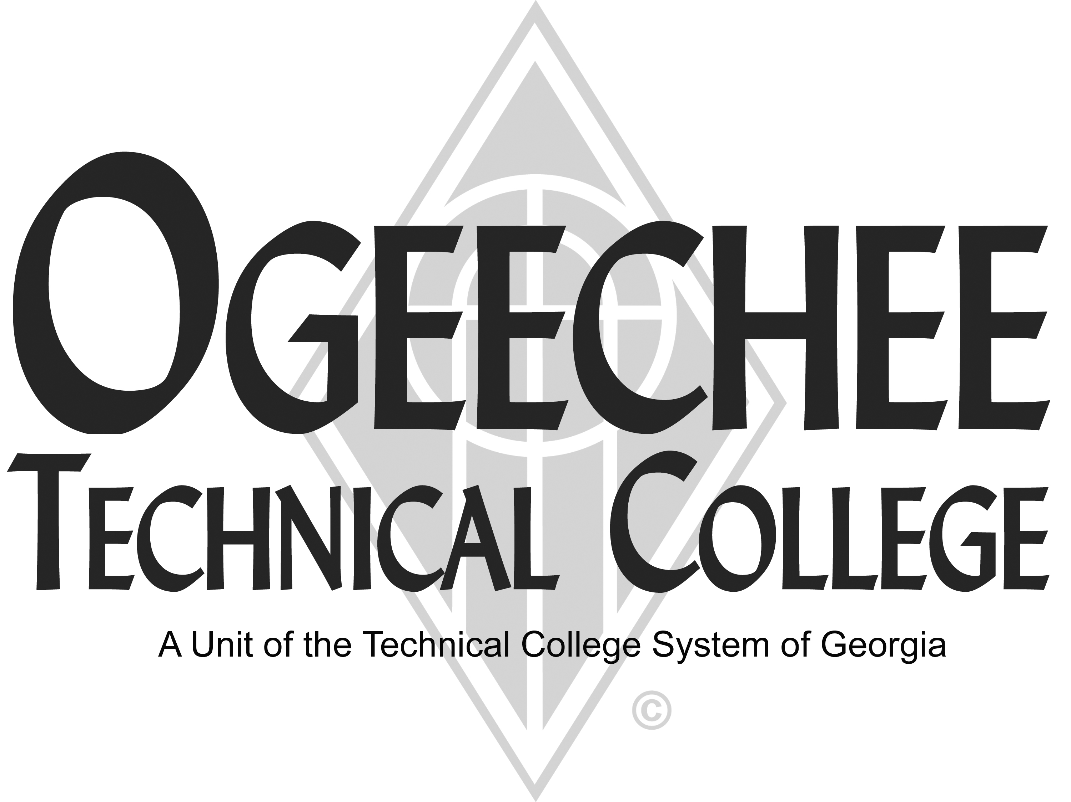
POSITION ANNOUNCEMENT
POSITION TITLE: | Part-Time Tutor
 | This is an applicant pool – active position may not be available
POSITION DESCRIPTION:
The general responsibilities of the tutor are to provide academic tutorial assistance for OTC students. Tutor will assist students in achieving a better understanding of specific subject material and in improving academic capabilities in designated areas. The tutor will help students develop positive attitudes toward learning and studying. The tutor will establish and maintain rapport with the assigned student(s). The tutor will be responsible for maintaining records on each student who is being tutored. The tutor will provide feedback to the Student Navigator (Coordinator of the Academic Enrichment Center) regarding the progress of students.
MINIMUM QUALIFICATIONS:
- Proven achievement in the assigned subject area(s).

PREFERRED QUALIFICATIONS:
- None
SALARY/BENEFITS:
$15.00 hour. Non-benefitted position
APPLICATION DEADLINE:
Open Until Filled
TO APPLY: Please submit an online application using the OTC online job center website. A criminal history records check is required as a condition of employment. Copies of all transcripts should be submitted at the time of application for faculty positions. Official transcripts are required upon employment. For more information, please contact the Director for Human Resources at employment@ogeecheetech.edu
As set forth in its student catalog, Ogeechee Technical College does not discriminate on the basis of race, color, creed, national or ethnic origin, gender, religion, disability, age, political affiliation or belief, genetic information, veteran status, or citizenship status (except in those special circumstances permitted or mandated by law). The following individuals have been designated to handle inquiries regarding the nondiscrimination policies: Christy Rikard, Ogeechee Technical College One Joseph E. Kennedy Blvd., Office 191, Joseph E. Kennedy Building, Statesboro, GA 30458, 912.486-7607, crikard@ogeecheetech.edu and Sabrina Burns, ADA/Section 504 Coordinator, Ogeechee Technical College, One Joseph E. Kennedy Blvd., Office 711, Joseph E. Kennedy Building, Statesboro, GA 30458, 912.486.7211, sburns@ogeecheetech.edu

