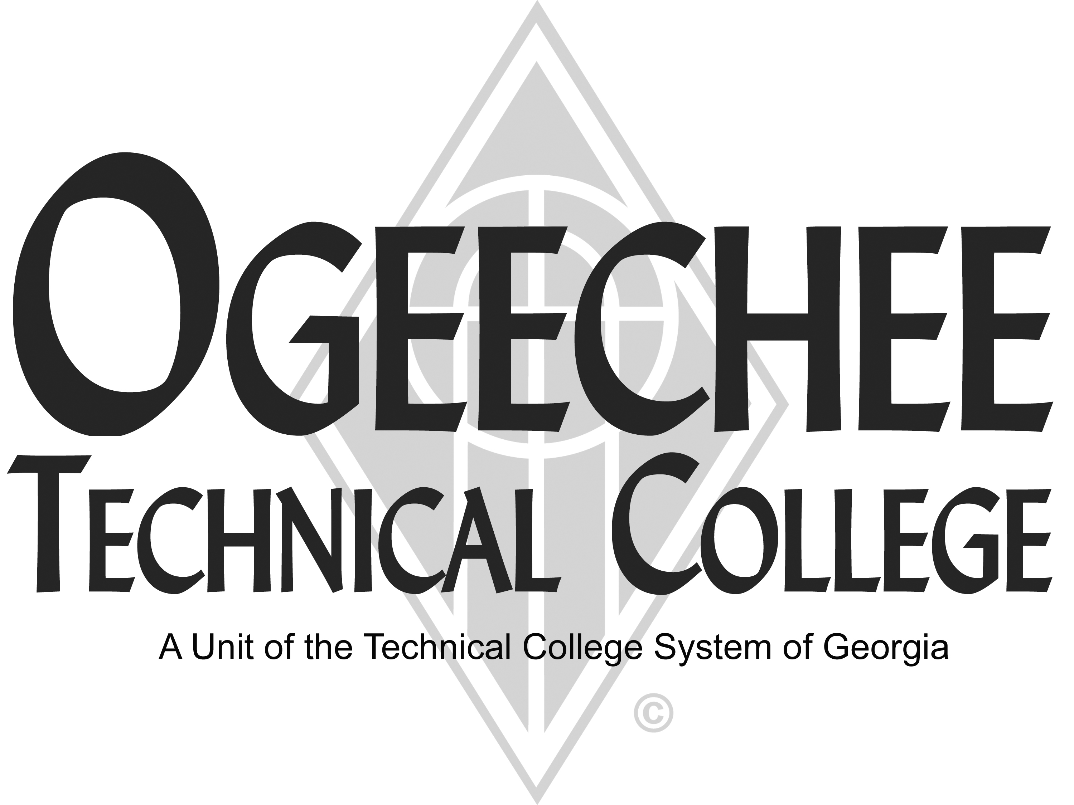

POSITION ANNOUNCEMENT
POSITION TITLE: | Admissions Assistant
POSITION DESCRIPTION:
Under general supervision, the Admissions Assistant is responsible for: performing administrative, clerical, admissions and customer service duties in support of the Student Affairs Division at Ogeechee Technical College; responds to requests and needs of visitors and students; keeps abreast of admissions regulations, policies and procedures; provides information by telephone, written correspondence and in person to interested parties regarding applicant procedures and admissions requirements; maintains inventory of admissions materials; processes new student applications and related information and prepares student files; assists with special event planning and execution; coordinates campus visits and assists with group tours; monitors use of and maintains supplies and equipment; may assist with recruiting and marketing activities; may assist with registration duties; may supervise work study students, and other duties as assigned.
MINIMUM QUALIFICATIONS:
- High School Diploma or equivalent
- One (1) year of work-related experience
PREFERRED QUALIFICATIONS:
- Associates degree
- Experience with the BANNER Student Information System
SALARY/BENEFITS:
Commensurate with qualifications. Benefits include paid state holidays, annual and sick leave, retirement options, and State of Georgia Flexible Benefits package.
APPLICATION DEADLINE: Open Until Filled
TO APPLY: Please submit an online application using the OTC online job center website. All positions require a pre-employment criminal background investigation, education, and employer/professional reference checks. Some positions may additionally require a motor vehicle record search, credit history check, and/or drug screen. All male applicants between the ages of 18 and 26 years of age must present proof of Selective Service Registration. Copies of all transcripts should be submitted at the time of application for faculty positions. Official transcripts are required upon employment. For more information, please contact the Director for Human Resources at 912.871.1801 or employment@ogeecheetech.edu.

As set forth in its student catalog, Ogeechee Technical College does not discriminate on the basis of race, color, creed, national or ethnic origin, gender, religion, disability, age, political affiliation or belief, genetic information, veteran status, or citizenship status (except in those special circumstances permitted or mandated by law). The following individuals have been designated to handle inquiries regarding the nondiscrimination policies: Christy Rikard, Title IX Coordinator, Ogeechee Technical College One Joseph E. Kennedy Blvd., Office 198C, Joseph E. Kennedy Building, Statesboro, GA 30458, 912.486.7607, crikard@ogeecheetech.edu and Sabrina Burns, ADA/Section 504 Coordinator, Ogeechee Technical College, One Joseph E. Kennedy Blvd., Office 711, Joseph E. Kennedy Building, Statesboro, GA 30458, 912.486.7211, sburns@ogeecheetech.edu.

