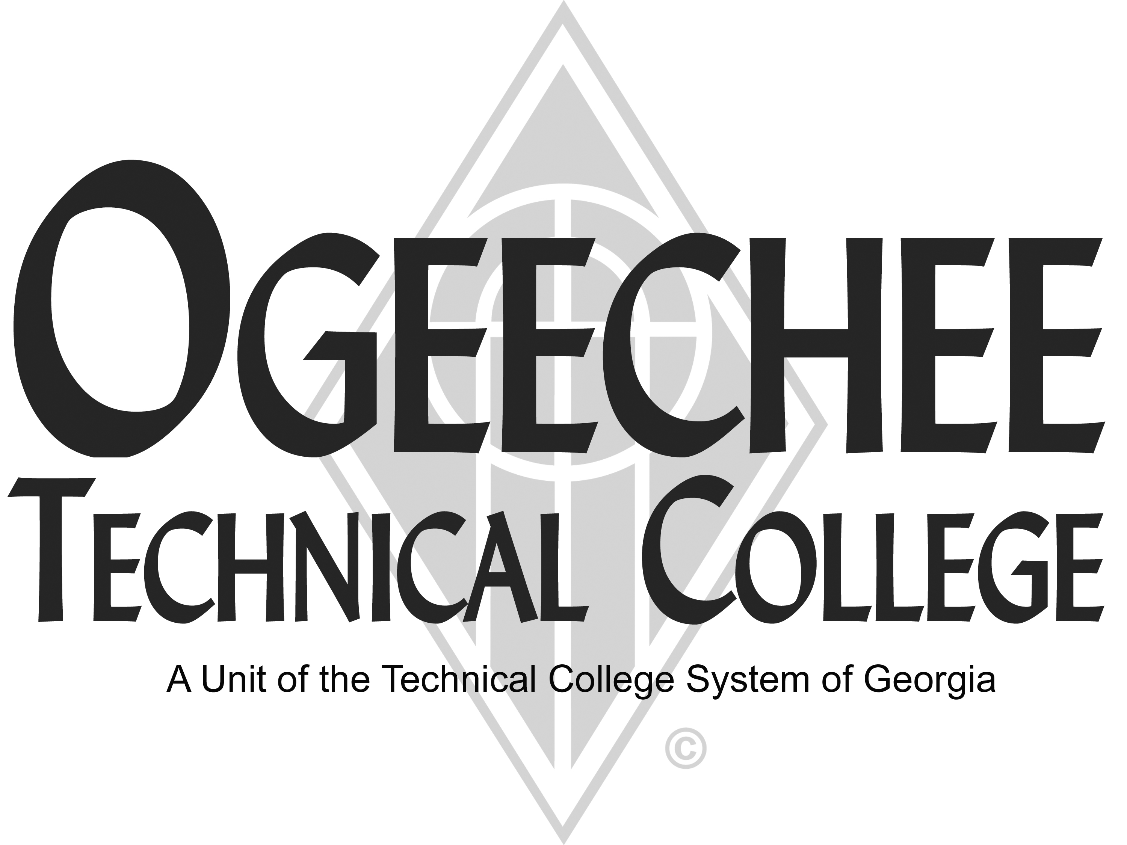
POSITION ANNOUNCEMENT(S)
POSITION TITLE:
Adjunct Esthetician Instructor
This is an applicant pool – active position may not be available
POSITION DESCRIPTION:
Responsible for teaching courses in the Cosmetic Esthetician program. Under general supervision, prepares lesson plans and develops program and syllabi, goals and objectives. Evaluates students’ progress in attaining goals and objectives. Maintains program certification requirements, as appropriate. Prepares and maintains all required documentation and administrative reports. Ensures safety and security requirements are met in the training area. Meets with students, staff members and other educators to discuss students’ instructional programs and other issues. Assists with recruitment, retention and job placement efforts. Stays abreast of industry trends and related local needs.
MINIMUM QUALIFICATIONS:
- Completion of a diploma from a regionally accredited college in cosmetology or completion of a certificate in cosmetic esthetics;
- Esthetician and/or Master Cosmetologist license and at least 2 years of related work experience;
- Knowledge of State Board requirements on practical application and written testing and;
- Excellent human-relations, interpersonal skills, and strong verbal and written communication skills and ability to interact effectively with a diverse student population, and basic computer skills.
• Must pass a criminal background check
PREFERRED QUALIFICATIONS:
- Associate or Bachelor's degree in Business or closely related field from a regionally accredited college or university.
- Skilled and experienced in State Board requirements on practical application and written testing.
- Experience with instructor preparation, instruction, instructional methodologies, evaluation and assessment, and active participation in appropriate professional/occupational organizations.
SALARY/BENEFITS:
Commensurate with qualifications /Non-benefits eligible.
APPLICATION DEADLINE:
Open Until Filled

TO APPLY: Please submit an online application using the OTC online job center website. All positions require a criminal background investigation, education, and employer/professional reference checks. Some positions may additionally require a motor vehicle record search, credit history check, and/or drug screen. All male applicants between the ages of 18 and 26 years of age must present proof of Selective Service Registration. Copies of all transcripts should be submitted at the time of application for faculty positions. Official transcripts are required upon employment. For more information, please contact the Director for Human Resources at 912.871.1801 or employment@ogeecheetech.edu.
The following individuals have been designated to handle inquiries regarding the non-discrimination policies: For Title IX: Cindy Phillips, Office: 191, Phone: 912.871.1620, cphillips@ogeecheetech.edu. For ADA/Section 504: Sabrina Burns, Disability and Student Support Services Director, Office: 189, Phone: 912.486.7211, sburns@ogeecheetech.edu.
As set forth in its student catalog, Ogeechee Technical College does not discriminate on the basis of race, color, creed, national or ethnic origin, gender, religion, disability, age, political affiliation or belief, genetic information, veteran status, or citizenship status (except in those special circumstances permitted or mandated by law). The following individuals have been designated to handle inquiries regarding the nondiscrimination policies: Cindy Phillips, Ogeechee Technical College One Joseph E. Kennedy Blvd., Office 191, Joseph E. Kennedy Building, Statesboro, GA 30458, 912.871-1620, cphillips@ogeecheetech.edu and Sabrina Burns, ADA/Section 504 Director, Ogeechee Technical College, One Joseph E. Kennedy Blvd., Office 189, Joseph E. Kennedy Building, Statesboro, GA 30458, 912.486.7211, sburns@ogeecheetech.edu

